Exp No. | Input |  |  |  |  | Output or parameter to be predicted
 | Pulse On Time (Âµs) | Pulse Off Time (Âµs) | Servo Voltage (V) | Applied Current (A) | Angle of wire | Surface Roughness, Ra (Âµm) | Material Removal Rate (mm3/min) | Kerf Width(mm)
1 | 12 | 12 | 55 | 4 | 60 | 4.137 | 5.866 | 1.378
2 | 12 | 12 | 60 | 3.5 | 60 | 3.752 | 5.556 | 1.277
3 | 8 | 14 | 70 | 5 | 30 | 2.458 | 4.770 | 0.943
4 | 8 | 14 | 50 | 5 | 90 | 3.795 | 5.695 | 1.289
5 | 12 | 12 | 55 | 4 | 60 | 4.225 | 5.957 | 1.400
6 | 12 | 12 | 60 | 3.5 | 60 | 3.782 | 5.653 | 1.286
7 | 8 | 10 | 70 | 5 | 90 | 2.692 | 4.919 | 1.004
8 | 8 | 14 | 70 | 5 | 30 | 2.542 | 4.838 | 0.965
9 | 12 | 13 | 60 | 4 | 60 | 3.561 | 5.442 | 1.227
10 | 8 | 14 | 50 | 5 | 90 | 3.885 | 5.773 | 1.311
11 | 16 | 10 | 70 | 5 | 30 | 3.431 | 5.540 | 1.194
12 | 16 | 10 | 70 | 3 | 90 | 3.195 | 5.021 | 1.135
13 | 8 | 10 | 70 | 5 | 90 | 2.777 | 5.024 | 1.026
14 | 12 | 13 | 60 | 4 | 60 | 3.645 | 5.535 | 1.249
15 | 16 | 10 | 70 | 5 | 30 | 3.529 | 5.643 | 1.219
16 | 16 | 10 | 70 | 3 | 90 | 3.279 | 5.172 | 1.155
17 | 12 | 12 | 60 | 4.5 | 60 | 3.859 | 5.736 | 1.305
18 | 12 | 12 | 60 | 4.5 | 60 | 3.774 | 5.644 | 1.283
19 | 16 | 14 | 50 | 3 | 90 | 4.577 | 5.901 | 1.489
20 | 16 | 14 | 50 | 3 | 90 | 4.487 | 5.797 | 1.467
21 | 8 | 14 | 70 | 3 | 90 | 2.209 | 4.290 | 0.879
22 | 8 | 14 | 70 | 3 | 90 | 2.285 | 4.393 | 0.898
23 | 14 | 12 | 60 | 4 | 60 | 4.026 | 5.785 | 1.347
24 | 14 | 12 | 60 | 4 | 60 | 3.937 | 5.683 | 1.325
25 | 12 | 12 | 65 | 4 | 60 | 3.331 | 5.338 | 1.169
26 | 12 | 12 | 65 | 4 | 60 | 3.415 | 5.440 | 1.191
27 | 8 | 10 | 50 | 3 | 30 | 4.829 | 6.589 | 1.556
28 | 12 | 12 | 60 | 4 | 75 | 3.638 | 5.517 | 1.249
29 | 12 | 11 | 60 | 4 | 60 | 3.925 | 5.752 | 1.322
30 | 8 | 10 | 50 | 3 | 30 | 4.910 | 6.668 | 1.576
31 | 12 | 12 | 60 | 4 | 75 | 3.725 | 5.620 | 1.272
32 | 12 | 11 | 60 | 4 | 60 | 4.017 | 5.850 | 1.347
33 | 16 | 10 | 50 | 5 | 90 | 5.060 | 6.577 | 1.615
34 | 16 | 10 | 50 | 5 | 90 | 4.944 | 6.467 | 1.584
35 | 16 | 14 | 70 | 3 | 30 | 2.963 | 4.848 | 1.074
36 | 16 | 14 | 70 | 3 | 30 | 3.042 | 4.950 | 1.093
37 | 16 | 14 | 50 | 5 | 30 | 4.722 | 6.258 | 1.528
38 | 16 | 14 | 50 | 5 | 30 | 4.812 | 6.331 | 1.551
39 | 12 | 12 | 60 | 4 | 45 | 3.895 | 5.773 | 1.314
40 | 12 | 12 | 60 | 4 | 45 | 3.808 | 5.684 | 1.291
41 | 10 | 12 | 60 | 4 | 60 | 3.531 | 5.519 | 1.222
42 | 10 | 12 | 60 | 4 | 60 | 3.612 | 5.614 | 1.241

Output | XGB Hyperparameter | XGB R² | SVR Hyperparameter | SVR R² | KNN Hyperparameter | KNN R² | LSTM Hyperparameter | LSTM R²
ESR | n_estimators = 200, learning_rate = 0.05, max_depth = 4, subsample = 0.8, colsample_bytree = 0.8, min_child_weight = 3 | 0.904 | kernel = RBF, C = 50, epsilon = 0.1, gamma = scale | 0.883 | n_neighbors = 5, metric = Minkowski (p = 2), weights = uniform | 0.572 | {'LSTM_units': 32, 'Dense_units': 16, 'epochs': 200, 'batch_size': 8, 'optimizer': 'adam'} | 0.867
SRR | n_estimators = 200, learning_rate = 0.05, max_depth = 4, subsample = 0.8, colsample_bytree = 0.8, min_child_weight = 3 | 0.875 | kernel = RBF, C = 50, epsilon = 0.1, gamma = scale | 0.859 | n_neighbors = 5, metric = Minkowski (p = 2), weights = uniform | 0.637 | {'LSTM_units': 32, 'Dense_units': 16, 'epochs': 200, 'batch_size': 8, 'optimizer': 'adam'} | 0.827
KG | n_estimators = 200, learning_rate = 0.05, max_depth = 4, subsample = 0.8, colsample_bytree = 0.8, min_child_weight = 3 | 0.918 | kernel = RBF, C = 50, epsilon = 0.1, gamma = scale | 0.877 | n_neighbors = 5, metric = Minkowski (p = 2), weights = uniform | 0.793 | {'LSTM_units': 32, 'Dense_units': 16, 'epochs': 200, 'batch_size': 8, 'optimizer': 'adam'} | 0.896
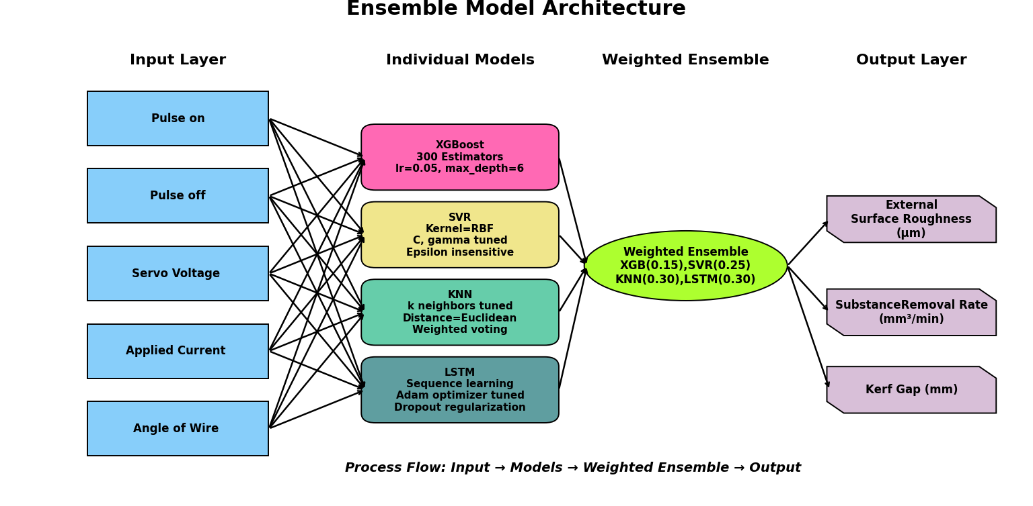
Table 5: Hyperparametrs for optimized models

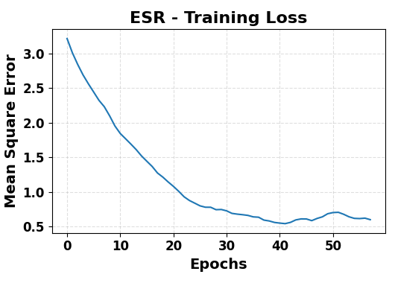
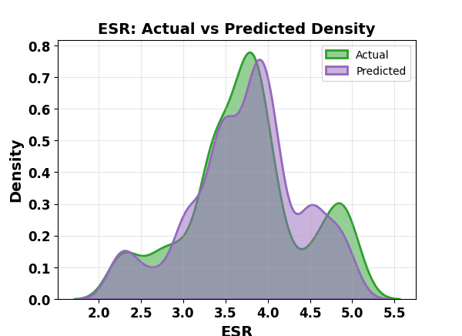
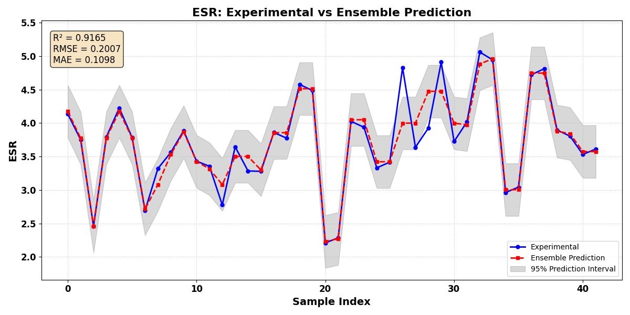
EXTERNAL SURFACE ROUGHNESS

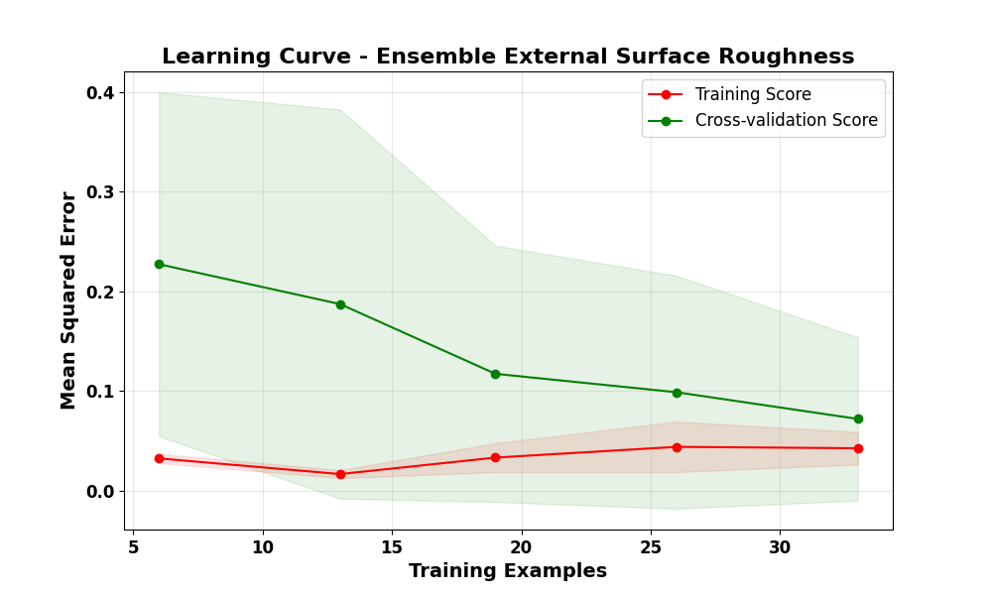
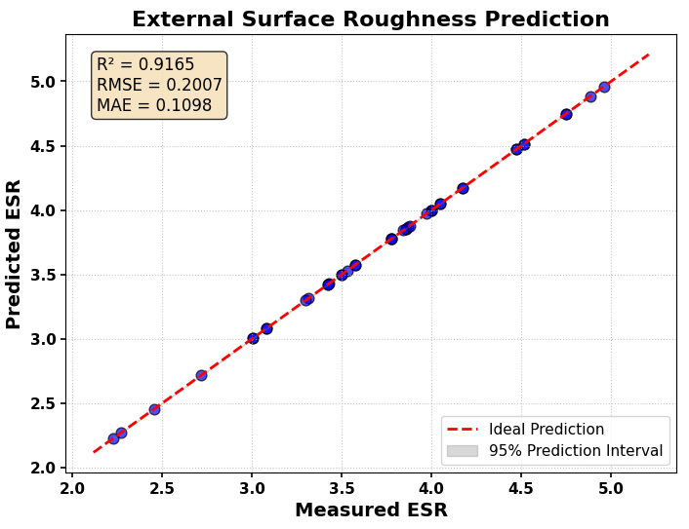
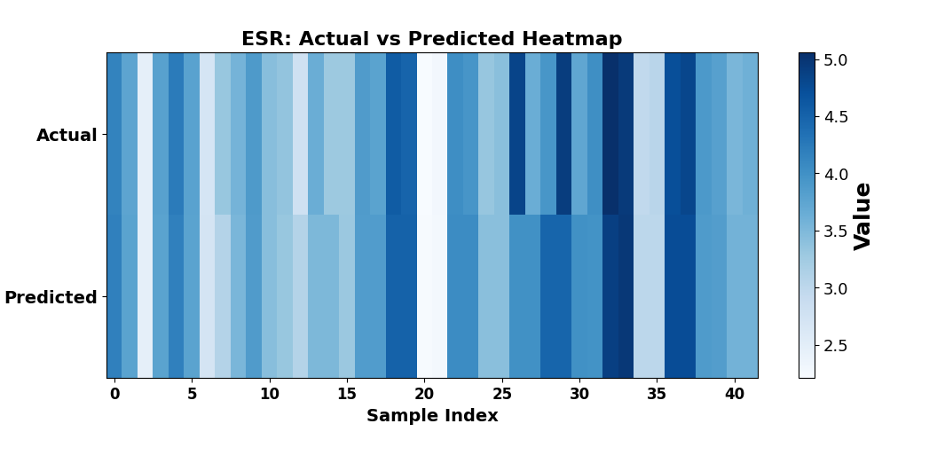

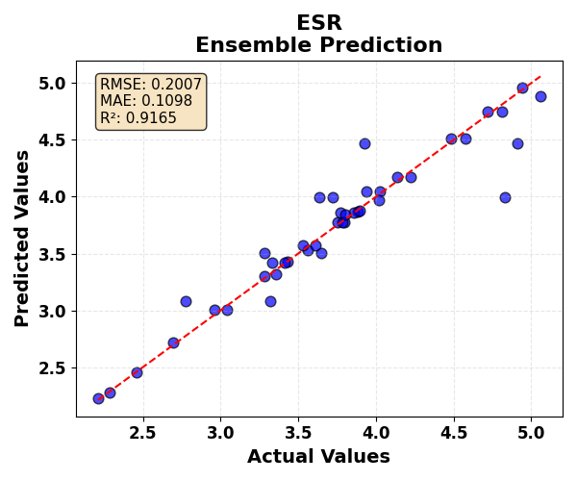
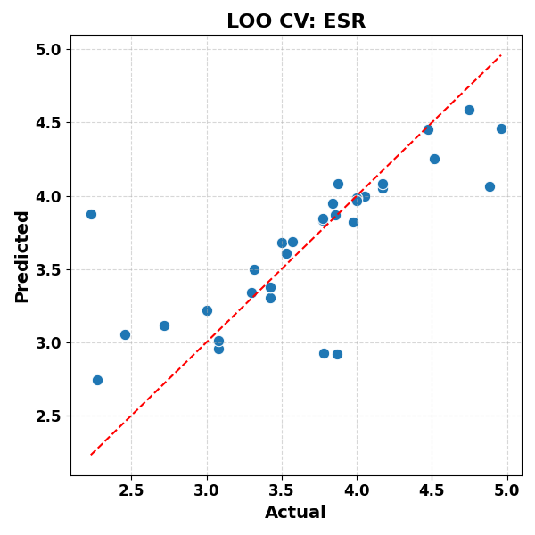

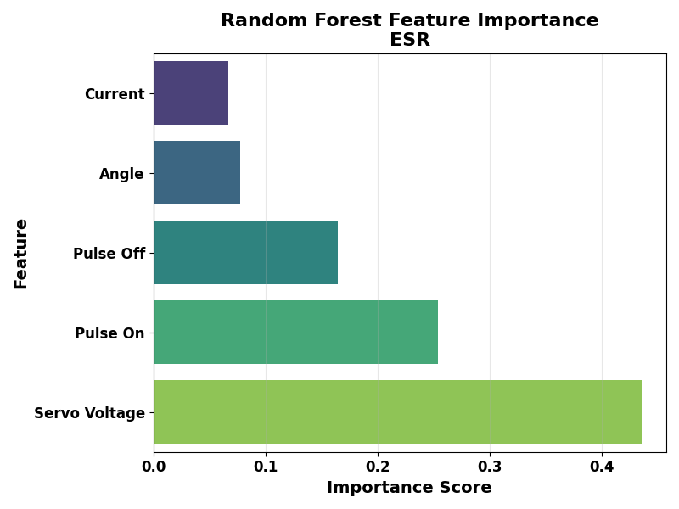
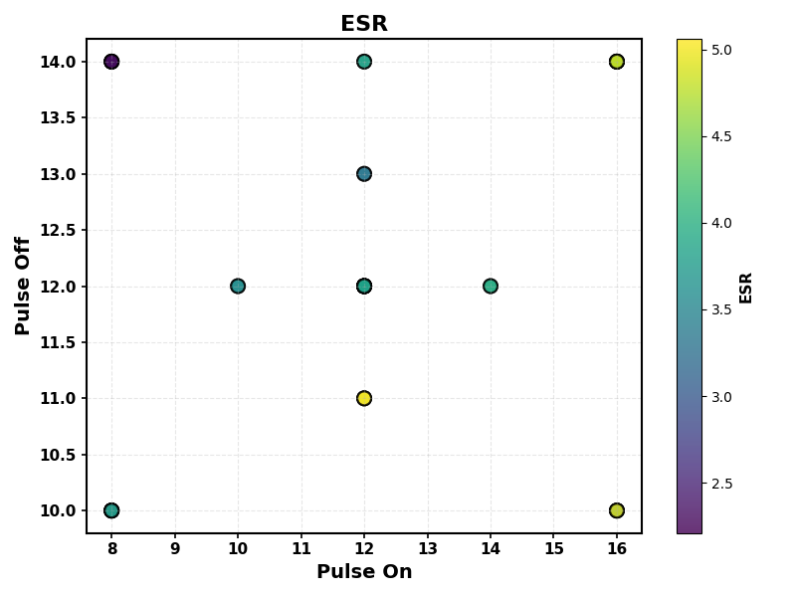
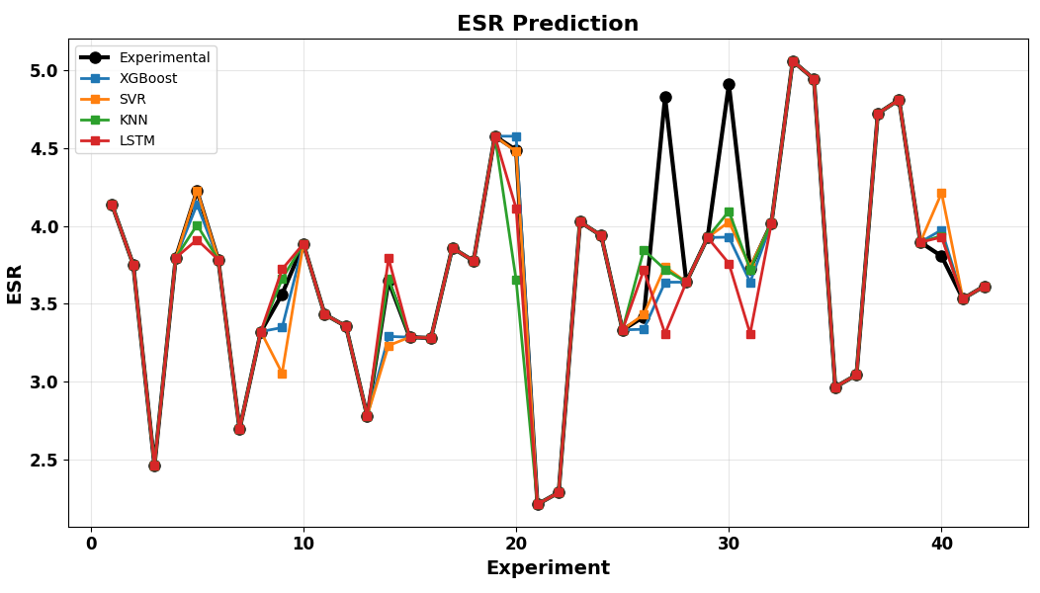

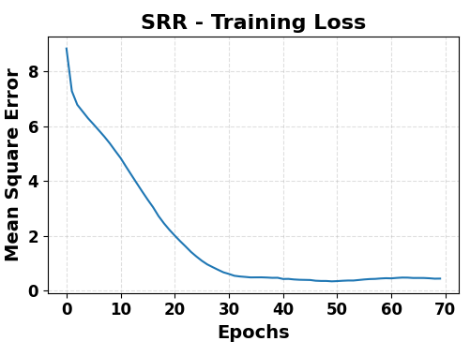
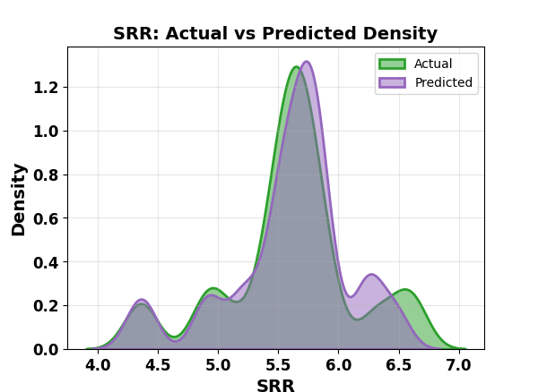
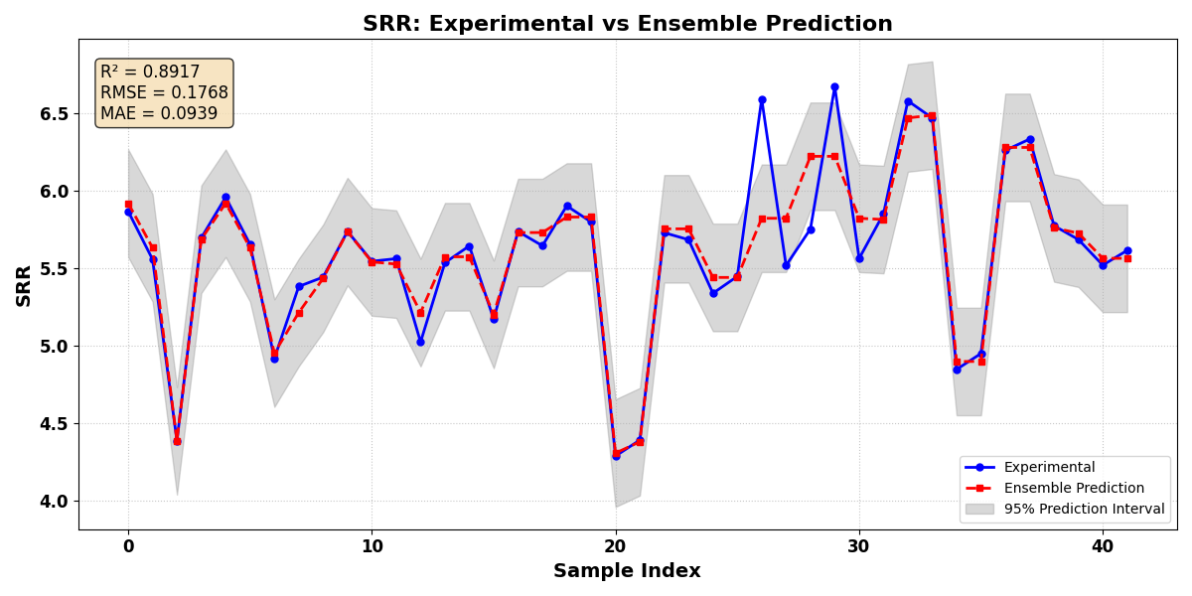
SUBSTANCE REMOVAL RATE

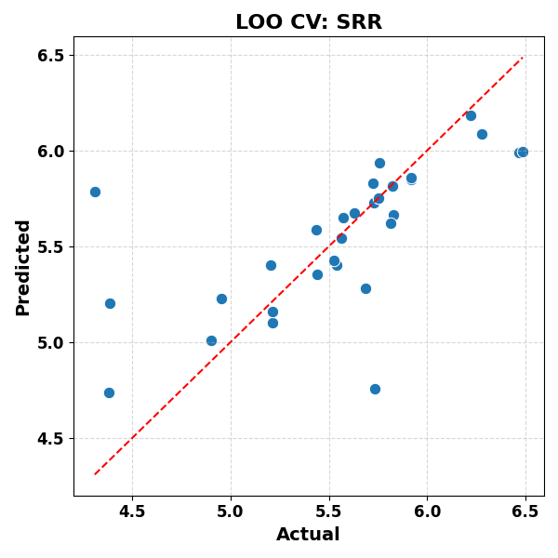
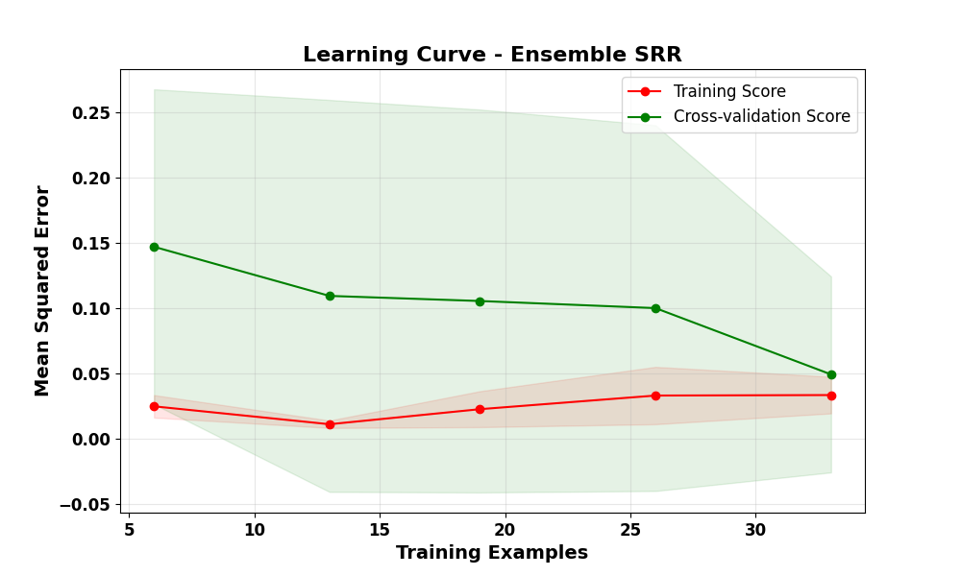
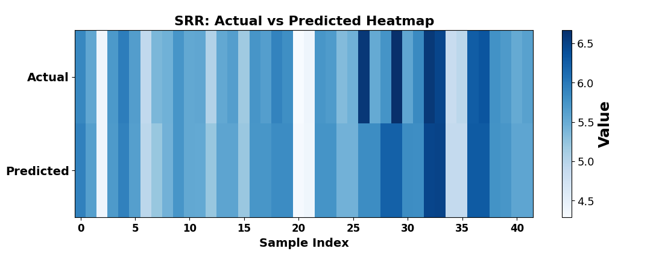

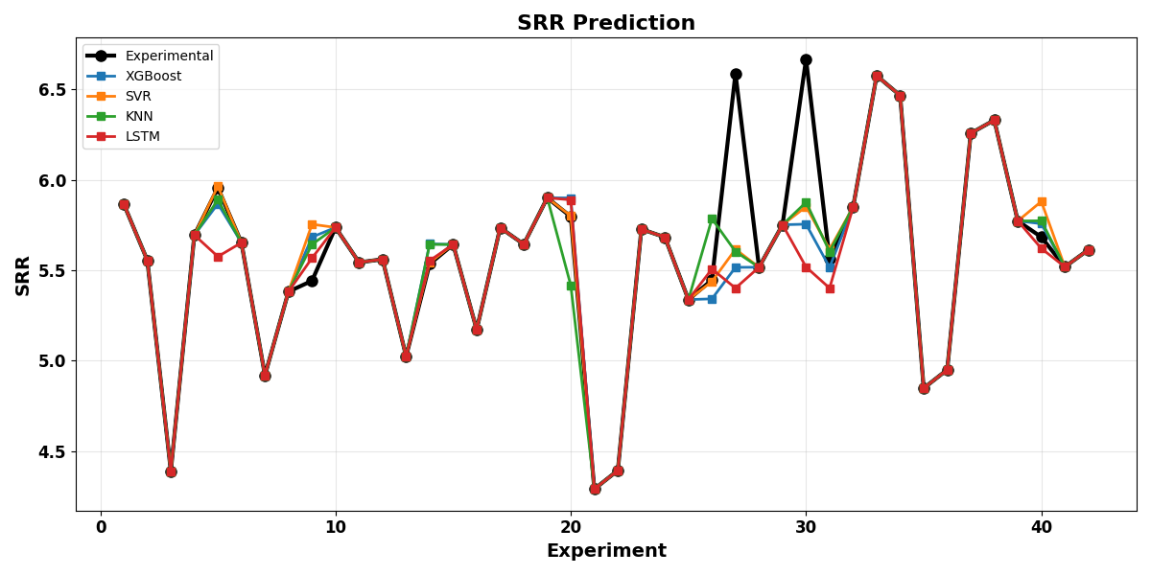
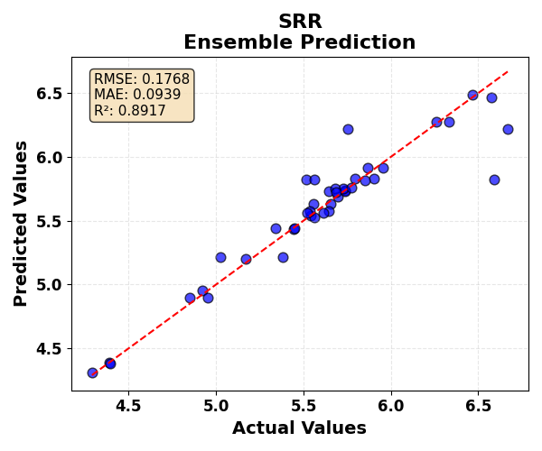

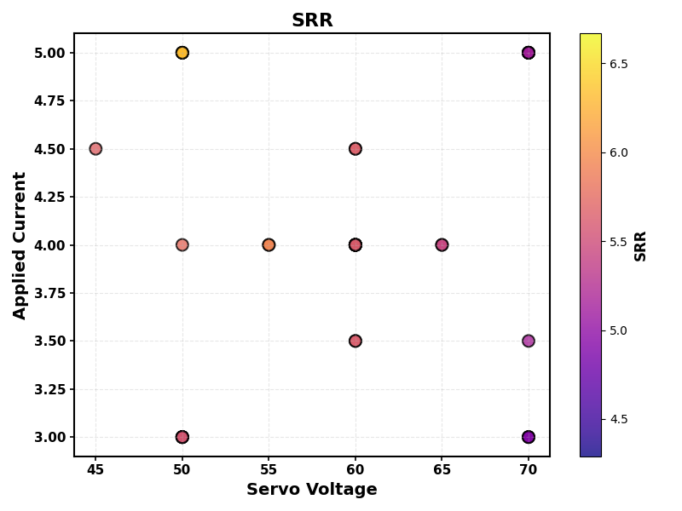

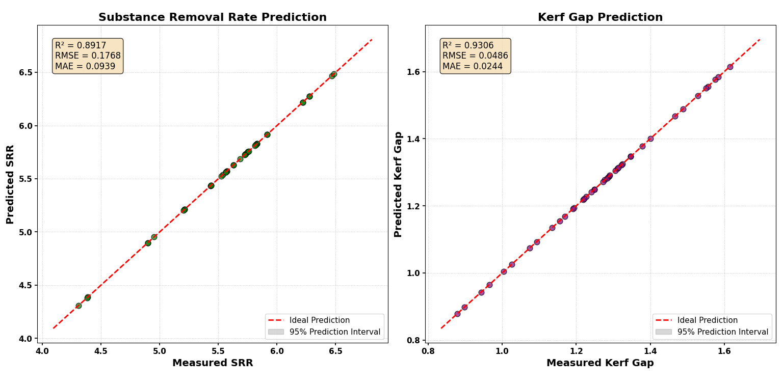
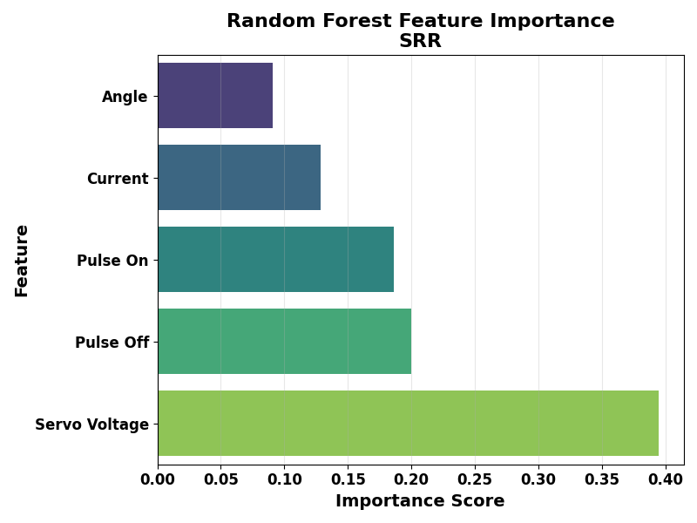

KERF GAP
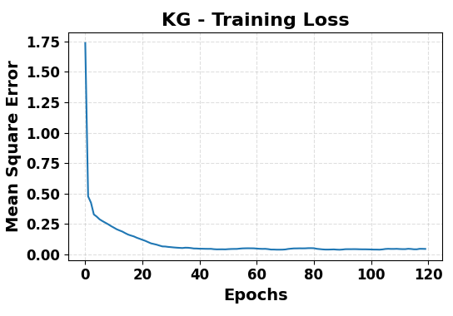
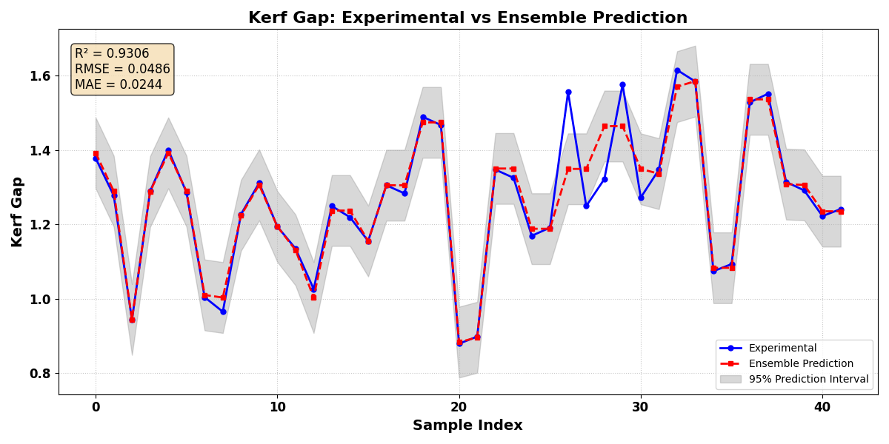

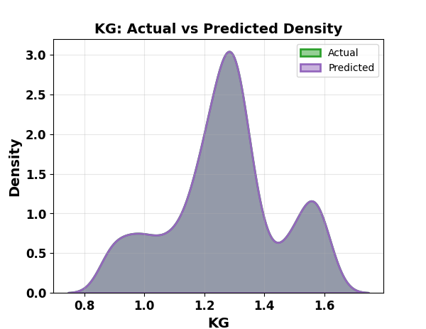

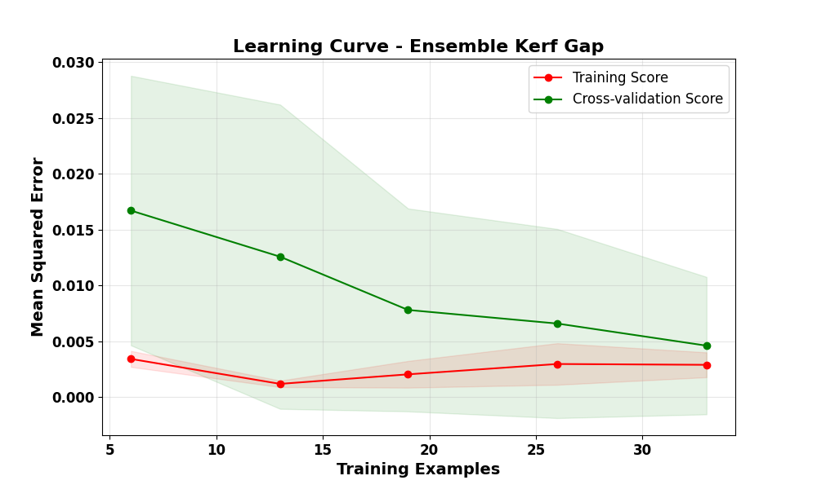

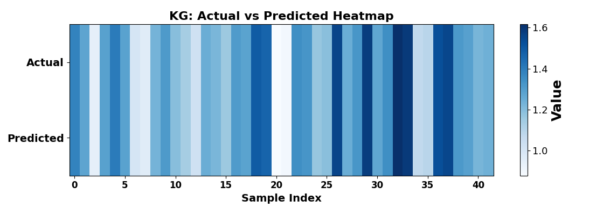

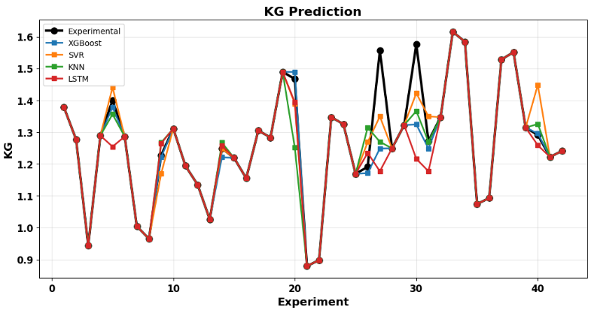
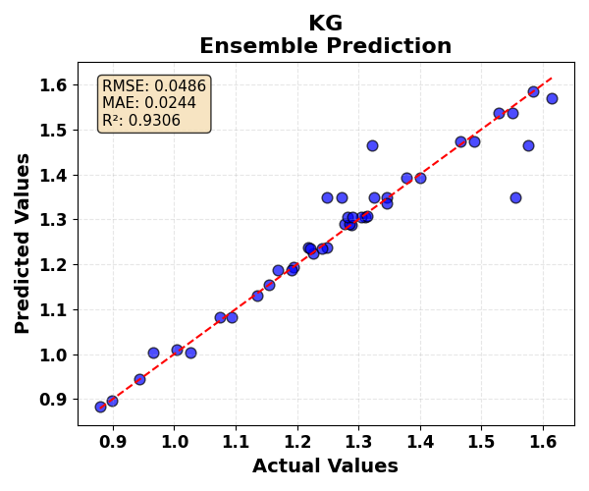
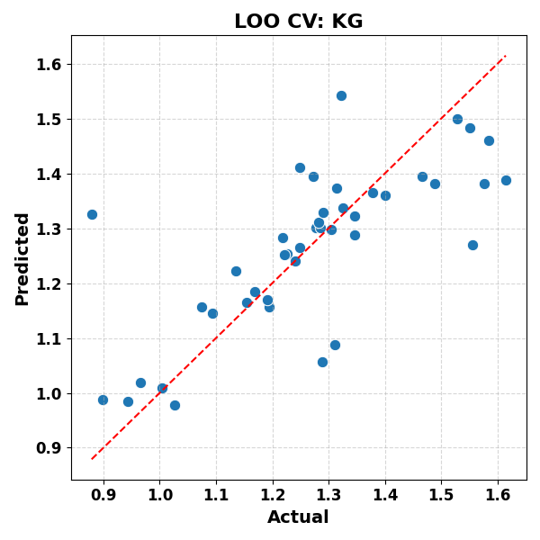

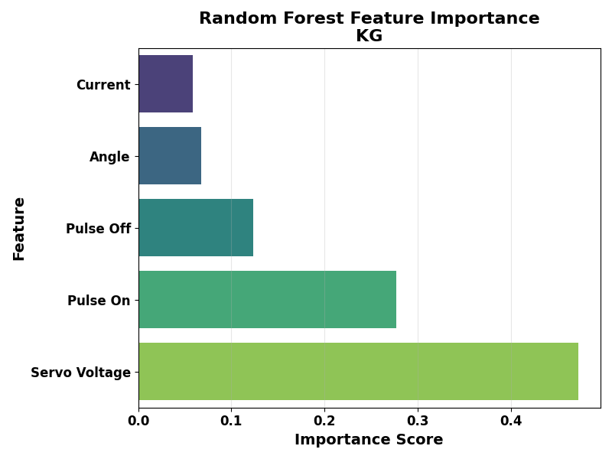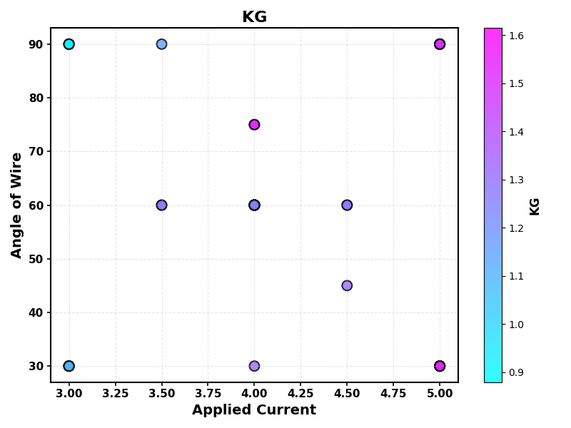
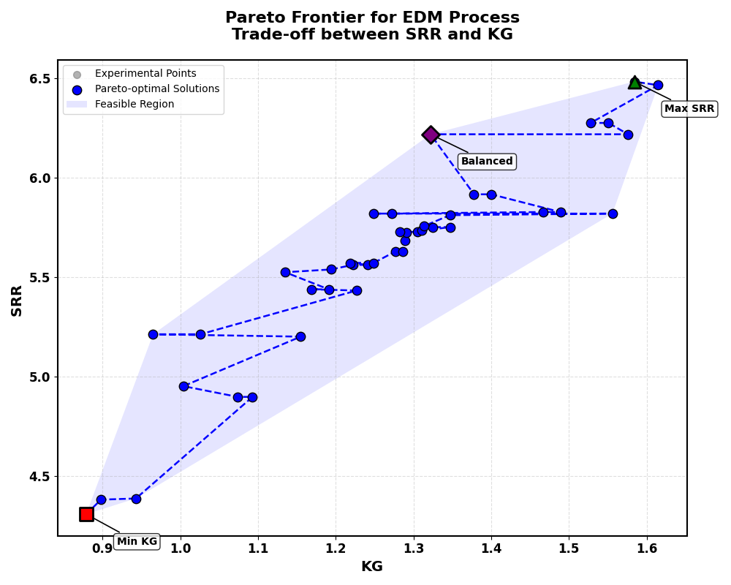

Parameter | Min KG | Max SRR | Balanced
Pulse On (µs) | 8 | 16 | 12
Pulse Off (µs) | 14 | 10 | 11
Servo Voltage (V) | 50 | 50 | 60
Current (A) | 3 | 5 | 4
Angle (°) | 90 | 90 | 75
KG (mm) | 0.879 | 1.584 | 1.322
SRR (mm³/min) | 4.309 | 6.485 | 6.22

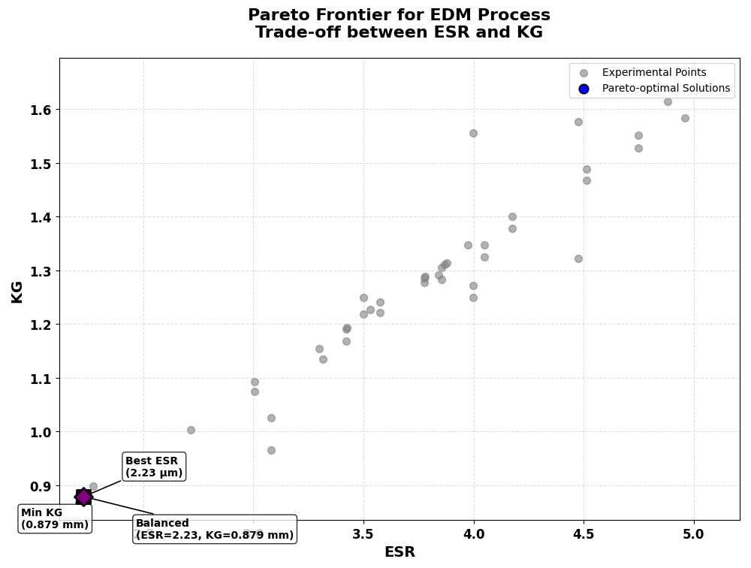

Parameter | Best Quality (Min ESR) | Min KG (mm) | Balanced
Pulse On (µs) | 8 | 8 | 8
Pulse Off (µs) | 14 | 14 | 14
Servo Voltage (V) | 50 | 50 | 50
Current (A) | 3 | 3 | 3
Angle (°) | 90 | 90 | 90
ESR | 2.229 | 2.229 | 2.229
KG | 0.879 | 0.879 | 0.879

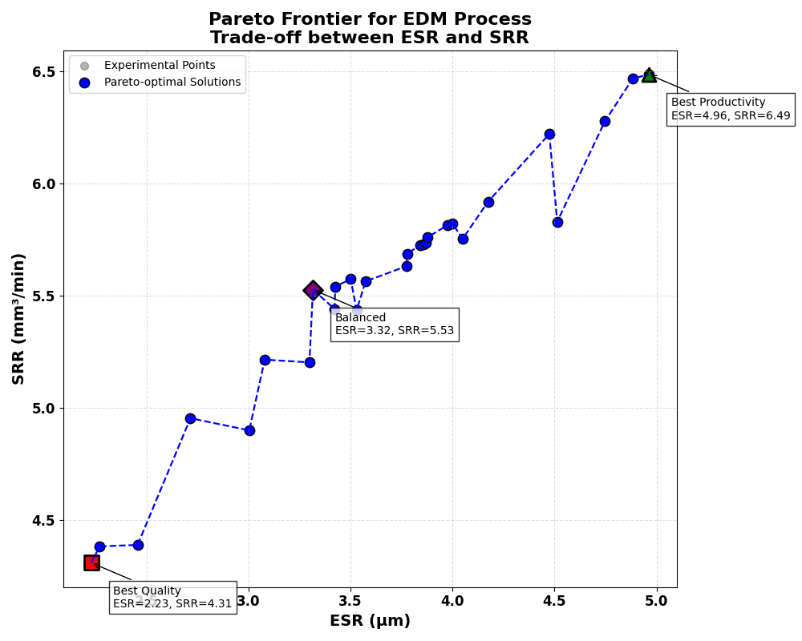

Parameter | Best Quality (Min ESR) | Best Productivity (Max SRR) | Balanced
Pulse_On | 8 | 16 | 16
Pulse_Off | 14 | 10 | 10
Servo_V | 50 | 50 | 70
Current | 3 | 5 | 5
Angle | 90 | 90 | 90
ESR | 2.229 | 4.961 | 3.316
SRR | 4.309 | 6.485 | 5.526

